Project:

This Risk Assessment has been produced specifically to address the issues around working in a construction environment during the COVID-19 outbreak. This risk assessment is subject to continuous review in consultation with the Group representatives. The Site Manager must always check that they have the latest version. This Risk Assessment must be read in conjunction with the associated task specific Risk Assessment.
Risk Management hierarchy principles must always be applied. For COVID-19 that is to follow the government guidelines and existing HSE legislation. As we move from the Governments Step 4 this requires specific consideration of workplace ventilation, cleaning and on-going personal hygiene.
This version of the Risk Assessment removes the specific requirement for 1+m / 2m social distancing restrictions but continues to require consideration of risk associated with any close working activities.
The below is a minimum requirement and must not be compromised, some working environments may have identified additional measures to comply with client site-specific assessments.

THIS RISK ASSESSMENT MUST BE BRIEFED TO OPERATIVES BEFORE LEAVING HOME AS IT INCLUDES HEALTH PRE-ASSESSMENT AND TRAVEL GUIDANCE

General Background Information:
Covid-19 is an illness that can affect your lungs and airways. It is caused by a virus called Coronavirus. Symptoms can be mild, moderate, severe or fatal and it can infect anyone of us

This risk assessment has been produced in accordance and compliance with Government and Group Guidance with any client specific requirements detailed below.

The purpose of this risk assessment and the mitigation actions and controls detailed is to protect you, your colleagues, your families and the event industry that we are part of. Please listen and please comply.

Symptoms vary from one person to another, that’s why it's important to recognise them. You are potentially infected by COVID-19 if you have the following symptoms:
- Fever and sweating
- A new persistent cough
- Loss of smell and / or taste
If you incur any of the above symptoms, isolate immediately and contact the NHS for a test. Keep your site / line manager informed.

COVID 19 contamination requires the virus to enter the respiratory tract (breathing bits!); access to which is via the:
- Mouth
- Eyes
- Nose

Transmission of the virus is therefore possible:
- By direct contact (e.g. handshake) - A person coughs in his hands and then greets a colleague by shaking his hand
- By projection (microdroplets) e.g. through talking, coughing, sneezing …
- By indirect contact with a contaminated surface (door handle, switches, controls etc. ...) e.g. A person coughs in his hands then operates equipment

Key actions are therefore:
- Where practicable avoid close working, face to face contact
- Wash your hands regularly, use the gel provided e.g. before eating / smoking, remove gloves and wash your hands. Put gloves back on before continuing work.
- Avoid touching your face e.g. use clean tissue to wipe sweat away
- Keep the equipment that you use clean, use the sanitising products provided
- Isolate immediately and request a test if any symptoms are experienced

Please ask questions if the controls briefed are unclear or you have any concerns

Client Specific Requirements:
This section is to include any client specific requirements above those detailed below e.g. client specific briefing process

Activity | Hazard | Who may be harmed | Pre-Mitigation Risk Score  (L x S) | Mitigation Actions / Controls | Post Mitigation Risk Score  (L x S) | Comments
Selection of operational staff | Spread of COVID-19 Coronavirus | - Employees  - Contractors | 4 x 5 = 20 | - As per NHS and government guidelines, anyone who has suspected symptoms (see above) must not be chosen to carry out the works and must self-isolate  - Anyone who has been in contact with a person with COVID-19 must not be chosen to work  - Any person who has underlying health conditions should consult with their line manager for a task specific assessment | 1 x 5 = 5
Travelling to and from site | Spread of COVID-19 Coronavirus | - Employees  - Contractors | 4 x 5 = 20 | - Site supervisor staff will where practicable travel alone  - Crews will travel in crew vehicles. Occupants shall avoids sitting face to face. See comments  - If possible, do not change driver, if this is required, the vehicle controls should be cleaned with a sanitising wipe  - If stopping for breaks on the journey, observe local request re spacing and face coverings  - Apply hand sanitiser prior to touching door handles or other surfaces  - Wash hands with soap and water for a minimum of 20 seconds after using toilets, before leaving the toilet area  - Reapply hand sanitiser once you have left the service area if you have touched any surface with your hands  - Wipe down steering wheel, door handles and gear stick if changing driver to reduced contamination risk  - The vehicle shall be ventilated as much as practicable. Air Circulation systems should not be used in vehicles. | 2 x 5 = 10 | GL events shall make face coverings available for use in company vans. Face coverings have minimal protection but do offer protection for those that come into contact with somebody who is asymptomatic i.e. not currently showing symptoms.  Disposable face covering must be bagged after use and disposed of in the general waste. Avoid touching the covering, wash hands after removal.  In the event that somebody starts to show symptoms i.e. coughing, visors and face coverings shall be worn in the vans whilst the individual is returned to a place of isolation.  If requested, visors can be made available to any member of staff requesting them for use whilst travelling.  Visors must be cleaned regularly with sanitizing fluid
Arrival at site | Spread of COVID-19 Coronavirus | - Employees  - Contractors  - Haulage Drivers  - Visitors  - Anyone else who physically comes in contact with you | 4 x 5 = 20 | - Park in the identified parking area, if possible, away from other contractors and users avoid unnecessary contact with others  - Initial contact with the client should be via phone to arrange any induction if required, preventing unnecessary close contact with other people  - Stores and materials will be unloaded in the lay down area. Where cross over of people is required, it should be kept a minimum  - If groups have travelled together, they should, where possible, be isolated as working groups on site | 2 x 5 = 10 | Note: Site Managers / Supervisors shall be responsible for ensuring parking arrangements are provided to allow appropriate social distancing from others
Works briefings | Spread of COVID-19 Coronavirus | - Employees  - Contractors  - Haulage Drivers  - Visitors  - Anyone else who physically comes in contact with you | 4 x 5 = 20 | - Briefings of the RAMS shall be undertaken by a Site Manager / Supervisor  - Where practicable, briefings shall be conducted in the open air  - Records of briefings shall be made by the Site Manager / Supervisor, attendance can be recorded by photo but not by passing of paper / tablet for signature | 2 x 5 = 10
Site set up | Spread of COVID-19 Coronavirus | - All site personnel | 4 x 5 = 20 | - Segregation of the site must be maintained at all times to prevent unauthorised persons entering the area  - All close proximity works shall be kept to a minimum  - To reduce cross contamination, gloves are to be worn during all site working activities, unless specifically identified in the Risk Assessment  - Once PPE has been issued to an individual, only that individual must use it. Do Not swap or share gloves / harnesses etc...  - Once gloves are removed e.g. for eating / smoking etc.., hands must be sanitised by either soap and water or hand sanitiser | 2 x 5 = 10
All site-based operations | Spread of COVID-19 Coronavirus | - All site personnel | 4 x 5 = 20 | Wearing of Gloves  - Appropriate cut-rated gloves are to be worn during all site working activities, unless specifically identified in the Risk Assessment  - Where medical type gloves are required, staff will be instructed on how to remove gloves carefully to reduce contamination and how to dispose of them safely. | 2 x 5 = 10 | - Staff to be reminded that wearing gloves is not a substitute for regular hand washing  This is particularly important for any medical / First Aid treatment on-site
All site-based operations | Spread of COVID-19 Coronavirus | - All site personnel | 4 x 5 = 20 | Hand Washing  - Hand washing facilities with soap and hot water in place  - If no immediate access to soap and water, then use alcohol-based hand-gel if available  - Stringent hand washing taking place  - Paper towels/tissue rolls for drying of hands  - Gel sanitisers in any area where washing facilities not readily available  - See hand washing best practice guidance (Below) | 2 x 5 = 10 | - Employees to be reminded on a regular basis to wash their hands for 20 seconds with warm water and soap and the importance of proper drying.  - Also reminded to catch coughs and sneezes in tissues (Catch it - Bin it - Kill it) and to avoid touching face, eyes, nose or mouth with unclean hands. Tissue to be made available throughout the workplace.
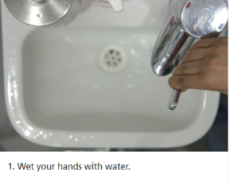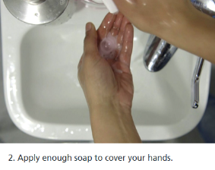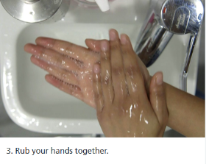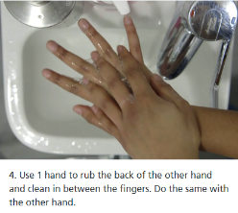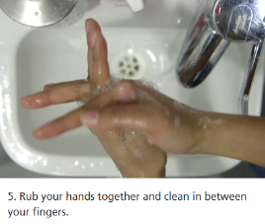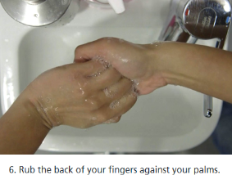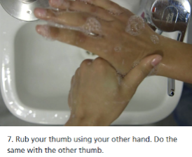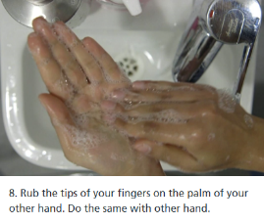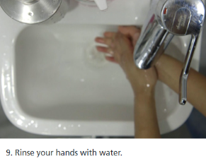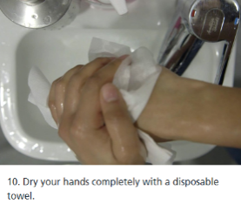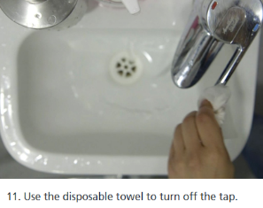

All site-based operations | Spread of COVID-19 Coronavirus | - All site personnel | 4 x 5 = 20 | Cleaning / Sanitising  - Frequently cleaning and disinfecting objects and surfaces that are touched regularly particularly in areas of high use using appropriate cleaning products.  - Particular attention to tools, machinery door handles and switches  Cleaning can be achieved using a diluted bleach solution on a cloth or using sanitizing wipes. | 2 x 5 = 10 | - Minimum - as part of the daily pre-start equipment inspections  - Checks to be carried out by Site Mangers to ensure that these procedures are being completed
All site-based operations | Spread of COVID-19 Coronavirus | - All site personnel | 4 x 5 = 20 | Social Distancing  - Social Distancing - Reducing the number of persons in any work area to comply with the 2m gap recommended by Public Health England  - Review work schedules including start and finish times to reduce number of workers on site at any one time. Also relocating workers to other tasks.  - Redesign working processes to minimum close working  - Conference calls to be used instead of face to face meetings – remote safety inspections  - Enough phased rest breaks for staff  - Social distancing to be maintained in canteen and smoking areas | 3 x 5 = 15 | - All site staff to be reminded daily of the importance of social distancing both in the workplace and outside of it  - Site Managers to ensure this is adhered to
All site-based operations | Spread of COVID-19 Coronavirus | - All site personnel | 4 x 5 = 20 | Mental Health  - Management will promote mental health & wellbeing awareness to staff during the Coronavirus outbreak and will offer whatever support they can to help | 2 x 5 = 10 | - Regular communication of mental health information and open-door policy for those who need additional support
All site-based operations | Spread of COVID-19 Coronavirus | - All site personnel | 4 x 5 = 20 | Symptoms of Covid-19  - If anyone becomes unwell with a new continuous cough or a high temperature in the workplace, they will be sent home and advised to follow the stay at home / self-isolation guidance (See comments)  - Line managers will maintain regular contact with staff members during this time | 3 x 5 = 15 | If a worker develops a high temperature, a new continuous cough, or a loss of, or change in, their normal sense of taste or smell while at work, they should:  - Ensure their manager or supervisor is informed  - Return home immediately  - Avoid touching anything  - Cough or sneeze into a tissue and put it in a bin, or if they do not have tissues, cough and sneeze into the crook of their elbow.  They should get a Coronavirus (Covid-19) test.  They must then follow the guidance on self-isolation and not return to work until they have received a negative test result or, in the event of a positive test result, their period of self-isolation has been completed.
Construction (Plant) | Spread of COVID-19 Coronavirus | - All site personnel | 4 x 5 = 20 | - Before using, plant, door handles / controls shall be wiped with a sanitising cloth  - Where possible, only one nominated person shall operate any item of plant to avoid cross contamination | 2 x 5 = 10
Construction (Hand tools) | Spread of COVID-19 Coronavirus | - All site personnel | 4 x 5 = 20 | - Before using Hand tools wipe with sanitising wipes  - Where possible do not share hand tools  - Wipe hand tools at end of use / activity | 2 x 5 = 10
Use of Welfare Areas | Spread of COVID-19 Coronavirus | - Employees  - Contractors  - Haulage Drivers  - Visitors  - Anyone else who physically comes in contact with you | 4 x 5 = 20 | - Adequate welfare (toilets, hand washing facilities etc) are to be available  - Do not over crowd welfare areas.  - If the welfare area is busy you must wait outside until it is safe to enter  - Maintain good hand hygiene before touching any surface on the way in and out | 3 x 5 = 15 | - Client responsibility – Site Manager / Supervisor to monitor
Leaving Site | Spread of COVID-19 Coronavirus | - Employees  - Contractors  - Haulage Drivers  - Visitors  - Anyone else who physically comes in contact with you | 4 x 5 = 20 | - Remove all waste products to the van for disposal  - All used gloves to be disposed of in bags  - Wash hands before returning to vehicles and wash hands again when arriving at home  - Used PPE should be kept separate when returning home e.g. leave in van / bag up, except when being washed  - PPE / Work Wear should be cleaned (see comments)  - When at home do not share IT equipment e.g. phones, tablets etc.. with other home users | 2 x 5 = 10 | PPE and Work clothes should be washed in a normal wash, no need to separate from other washing or special washing detergents

Risk Criteria Applied

0 – 5  Low Risk  6 – 10  Moderate Risk  11 – 15  High Risk  16 – 25  High Risk | 1 | 2 | 3 | 4 | 5
5  Certain | 5 | 10 | 15 | 20 | 25
4  Probable | 4 | 8 | 12 | 16 | 20
3  Possible | 3 | 6 | 9 | 12 | 15
2  Unlikely | 2 | 4 | 6 | 8 | 10
1  Remote | 1 | 2 | 3 | 4 | 5

Control measures shall always be selected using the hierarchy of risk control where reasonably practicable i.e. Eliminate, Reduce, Isolate, Control

